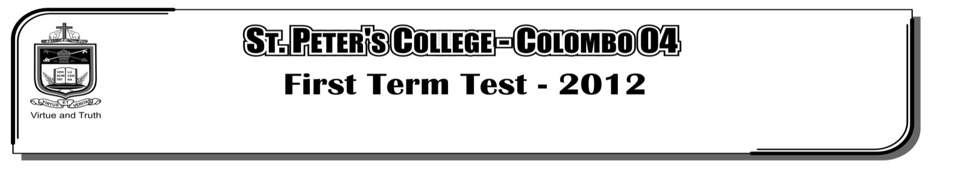

**FIRST TERM TEST - 2019**

**GRADE 10 – Physical Education**

**Part I**

Answer all question,

01. How many main skills are there in the volleyball game,

i. 7 ii. 6 iii. 5 iv. 8

02. The factor which helps to maintain the balance in the body is,

i. Location of the center of gravity below the support base.

ii. The support base being very small.

iii. Movements in limbs in the opposite directions.

iv. Weight of the body.

03. Every step of race walking consist of __________ stages.

i. One ii. Two iii. Three iv. None

04. Relay race is one of the track event what is the distance of the batton changing zone ?

i. 10 m ii. 10 Feet iii. 30 m iv. 20 Feet

05. What is the combined event that both men and women can participate in?

i. Pentathlon ii. Heptathlon iii. Decathlon iv. All combined events.

06. What is the bio mechanical principle that affect on posture?

i. Flexibility ii. Speed iii. Balance iv. Strength

07. What is the factor needed to optimally balance the body weight of a person,

i. Work in a good personality ii. Punctually

iii. Wide supporting phase iv. Good nutrition

08. How high from the feet, is the center of gravity situated,

¸' 60% ¸¸' 56% ¸¸¸' 70% ¸¹' 48%

09. When feet are kept together, the balance of the body is,

i. Increased ii. Decreased

iii. Does not change iv. Doubles

10. The duration of a single round in a game of football is,

i. 30 minutes ii. 45 minutes iii. 60 minutes iv. 5 minutes

11. Which is not an outdoor activity?

i. Campfire game ii. Boat riding iii. Field trip iv. Chess

12. Who is not a member of the team of Judges in volleyball?

i. 1st referee ii. Scorer iii. Second referee iv. Coach

13. Which is not a skill in netball ?

i. Service ii. Defending iii. Foot work iv. Shooting

14. Which is not a benefit of outdoor activity ?

i. Improvement of Self-confidence

ii. Build mutuality

iii. Ability to work alone

iv. Decrease efficiency

15. When seated, the centre of gravity is situated ?

i. On the knees ii. On the hips

iii. At the end of the spine iv. On the belly button

16. The starter of all rounds in volleyball is called ?

i. The server ii. The libero

iii. The receiver iv. The attacker

17. When hitting the ball in volleyball, the fingers should be,

i. Spread out ii. Flexed a little

iii. Relaxed iv. Brought together curvely

18. Maximum number of steps, when preparing for spiking is,

i. 2 steps ii. 1 step iii. 4 steps iv. 3 steps

19. The number of referees in a game of netball is ?

i. 1 ii. 3 iii. 4 iv. 2

20. Which is not a technique of a heading in football,

i. Heading without a jump

ii. Heading with a jump

iii. Heading a ball with the side of the head with a jump

iv. Heading while bending forwards